Deloitte Strategy & Operations Career Guide
Meta description: WSG founder Stephen Turban explains what Deloitte Strategy & Operations became: the analyst track, pay, the case interview, and the 2027 and 2028 timelines.

"Does Deloitte S&O still exist? My cousin did it in 2018 and I can't find it anywhere on their careers site."

That was Caleb, a junior at a large public university, on a first call with me in September. His cousin had told him that Deloitte Strategy and Operations was the Big 4 seat that felt most like MBB, so he spent an evening on apply.deloitte.com and found postings with names like "Consultative Offerings - Analyst - Enterprise Strategy" and nothing called S&O. He assumed the practice had been shut down.

I'm Stephen Turban. I went to Harvard, spent two years at McKinsey, and now run WSG, where I get a version of Caleb's question every fall. The short answer: the name is gone, the work isn't. Deloitte folded its Strategy & Operations service line into a set of offering portfolios years ago, reorganized again in 2024, and today the entry door is a track inside what it calls Consultative Offerings. This guide walks what S&O became, what the analyst job is, what it pays, how the interview runs, and when to apply for Summer 2027 and Summer 2028.

Does Deloitte still have a Strategy & Operations practice?
Not under that name: Deloitte Consulting retired "Strategy & Operations" as a service line when it moved to offering portfolios by about 2019 [VERIFY: year of the move to offering portfolios; WSO threads already describe portfolio offerings in June 2019], and its US campus postings in October 2026 carry the label "Consultative Offerings" with tracks such as Enterprise Strategy and Functional & Operations Strategy [VERIFY: current track names on apply.deloitte.com]. The strategy and operations work still exists at Deloitte; it has been renamed and resorted, not shut down. The strategy-only practice inside that structure is Monitor Deloitte, and I covered its pay, interviews and hiring in the Monitor Deloitte career guide. This article is about the wider Deloitte Consulting analyst track that absorbed S&O.

How is Deloitte S&O different from Monitor Deloitte?
Monitor Deloitte is the branded strategy practice (corporate, growth and M&A strategy) and Deloitte's US site now files it under Strategy & Transactions [VERIFY: Monitor Deloitte placement on deloitte.com/us]. S&O was broader and also covered operations transformation, supply chain, finance transformation and merger integration, the work that today shows up in the Functional & Operations Strategy track. Monitor is the strategy slice of what S&O used to be; the rest of S&O lives in the operations and functional strategy tracks that sit beside it. The case interview, the analyst title and the pay band are nearly the same across those tracks, so the choice is about the work you want, not the prestige.

What happened to Deloitte Strategy and Operations
Three reorganizations explain Caleb's confusion. Walk them in order and the current postings make sense.

Stage one, through about 2019. Deloitte Consulting hired undergrads into three groups: Strategy & Operations, Technology, and Human Capital. The S&O hire was a Business Analyst, the Technology hire was a Business Technology Analyst, and the Human Capital hire carried that practice's name in the title [VERIFY: historical titles; Glassdoor still lists "Business Analyst, Strategy and Operations" as a Deloitte title]. When your cousin or your club's alumni say "Deloitte S&O," this is the structure they joined. It was the group that did the MBB-style work: growth strategy, cost programs, supply chain, M&A.

Stage two, about 2019 to 2024. Deloitte didn't shut S&O down; it stopped organizing by service area and started organizing by what it sells, and the names changed with it. The portfolios were Strategy & Analytics, Customer & Marketing, Core Business Operations, Enterprise Technology & Performance, Human Capital, and a Mergers & Acquisitions portfolio that later took on restructuring [VERIFY: portfolio names and dates; Deloitte member-firm pages still describe "Core Business Operations, Customer and Marketing, Enterprise Technology and Performance, Human Capital, and Strategy, Analytics and M&A"]. S&O, Technology and Human Capital didn't disappear. They became "talent groups," the skill family you belonged to, while the portfolio was the shelf your work got sold from. A former S&O consultant doing supply chain work now sat in Core Business Operations. One doing growth strategy sat in Strategy & Analytics, which is where Monitor Deloitte lived. This is the period that produced the secondary search term "Deloitte Strategy and Analytics," and it's why older guides describe Monitor as part of S&A.

Stage three, 2024 onward. In March 2024 Deloitte's global firm announced it would collapse five businesses into four: Audit & Assurance; Tax & Legal; Strategy, Risk & Transactions; and Technology & Transformation, with the change finishing across member firms by about mid 2025 [VERIFY: Deloitte global reorganization dates]. Since 2024 the old Consulting business has been split between Strategy, Risk & Transactions and Technology & Transformation, and the strategy and operations work sits on the first side. Deloitte's US consulting page now lists AI & Engineering, Cyber, Enterprise Performance, Human Capital, Strategy & Transactions, Regulatory, Risk & Forensic, Operate, and Customer under the Deloitte Digital name [VERIFY: deloitte.com/us consulting services page, October 2026]. The web address that used to serve the Strategy & Analytics portfolio now opens a page titled "Strategy & Business Design" and names the US Monitor Deloitte strategy offering leader as its contact [VERIFY: same page].

What a student sees in October 2026 is the campus version of stage three. Every undergrad consulting posting on apply.deloitte.com starts with "Consultative Offerings" and ends with a track:

- Enterprise Strategy, which the posting ties to a Strategy & Transactions path (corporate strategy, M&A, private equity, performance improvement, strategic choice advisory) plus Customer Strategy & Design, Supply Chain Strategy & Innovation, and Organization Workforce & Change [VERIFY: paths listed on the Enterprise Strategy Analyst posting]
- Functional & Operations Strategy, which lists Customer Strategy, Finance Transformation Strategy, Human Capital Strategy, Industry Operations, Infrastructure & Real Estate Strategy, Regulatory & Risk Strategy, and Supply Chain Strategy & Innovation [VERIFY: practices listed on the Functional & Operations Strategy posting]
- Enterprise Tech Strategy, which lists Engineering-as-a-Service, Enterprise Risk Strategy, Supply Chain Strategy & Innovation, and Tech & AI Strategy [VERIFY: posting]
- Technology Transformation (Packages, Platforms & AI), the implementation track built around SAP, Oracle, Salesforce, Workday and ServiceNow work [VERIFY: posting]
- AI Innovation, Infrastructure Engineering, and Cyber, the engineering-heavy tracks (Cyber is posted by Deloitte & Touche LLP rather than Deloitte Consulting LLP) [VERIFY: posting entity]

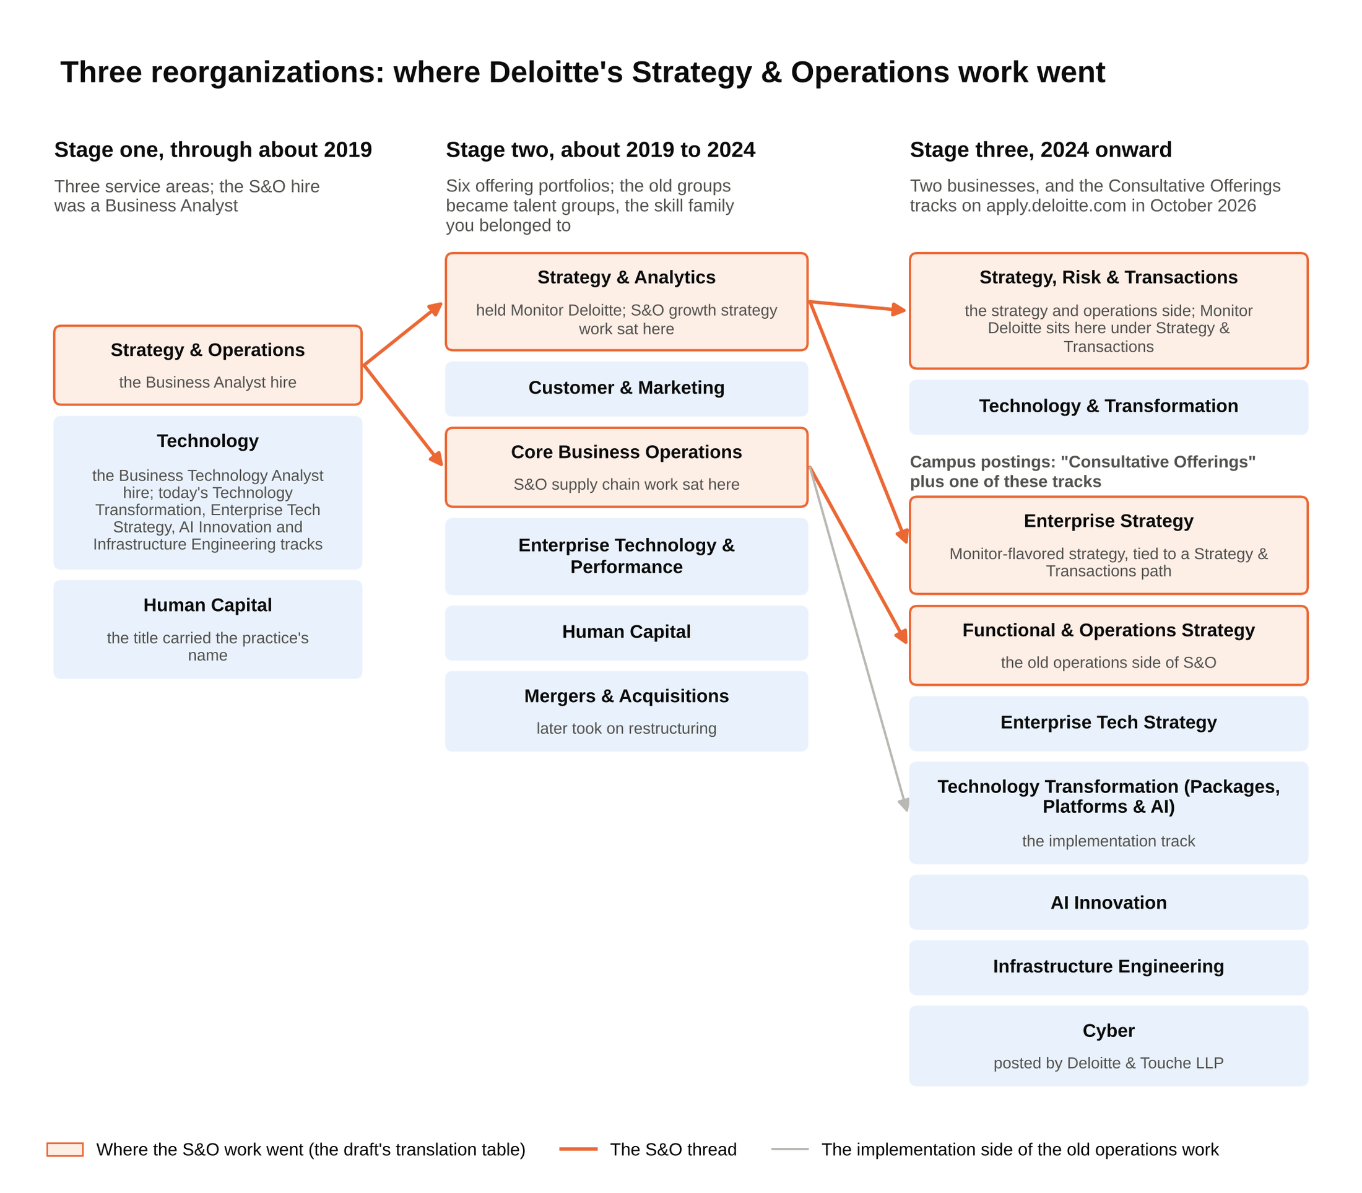
Follow the orange thread: S&O split into two portfolios in 2019, and today its work sits in the Enterprise Strategy and Functional & Operations Strategy tracks.

So here is the translation. When a student says "Deloitte S&O" today, the closest live postings are the Enterprise Strategy and Functional & Operations Strategy analyst tracks. Enterprise Strategy is where Monitor-flavored strategy work sits, and Functional & Operations Strategy is where the old operations side of S&O went. There was no separate Monitor Deloitte undergrad posting visible on the Deloitte job board when I checked in early October 2026; the path into that work runs through the Enterprise Strategy track [VERIFY: whether a Monitor-branded Business Analyst posting appears later in the cycle].

What people say | What it meant | Where it is now
Deloitte S&O, S&O Business Analyst | The strategy and operations service area, through about 2019 | Enterprise Strategy and Functional & Operations Strategy tracks under Consultative Offerings
Strategy & Analytics, S&A | The offering portfolio that held Monitor Deloitte, about 2019 to 2024 | Strategy & Transactions business; the old S&A page is now "Strategy & Business Design"
Core Business Operations, CBO | The operations and supply chain portfolio | Functional & Operations Strategy (strategy side) and Technology Transformation (implementation side)
Monitor Deloitte | The strategy practice Deloitte bought in 2013 | Still a named practice, inside Strategy & Transactions
Business Technology Analyst, BTA | The Technology service area's undergrad title | Technology Transformation, Enterprise Tech Strategy, AI Innovation and Infrastructure Engineering tracks

That table is tagged as a whole for the editor, because Deloitte renames things more often than any firm I follow [VERIFY: table mapping against the live postings at publish].

One piece of history makes the structure easier to remember. Monitor Group, founded in 1983 by a group that included Michael Porter, filed for Chapter 11 bankruptcy on November 7, 2012, and Deloitte bought substantially all of its business on January 11, 2013, for about $116 million [VERIFY: Forbes reported $116.2 million; Wikipedia gives the January 11, 2013 close]. A firm that once competed with McKinsey became a brand inside a Big 4 consulting arm. That's why Monitor is a practice name rather than a separate employer, and why the undergrad hire gets a Deloitte Consulting LLP offer letter whichever track they land in.

What the work actually is
The best way to understand the tracks is to look at the projects. Five kinds of project cover most of what the old S&O group did, and each one now has a named practice behind it. Here are the five, each with a fictional client and a plausible scope.

Operations transformation. A regional hospital network with eleven facilities has operating margins two points below its peers. A Deloitte team spends four months mapping how patients move from the emergency department to a bed, measures how long each handoff takes, and finds that discharge paperwork clears at 2 p.m. on average, so beds sit empty all morning while the ER backs up. The analyst builds the model that converts hours of bed time into dollars, then works with nurses on a 10 a.m. discharge target. This is the work that lives in Functional & Operations Strategy under Industry Operations.

Supply chain. A snack company with three plants and 40 distribution points keeps running out of its best seller in the Southeast while overstocking it in the Northwest. The team rebuilds the demand forecast by region, moves safety stock closer to the stores that sell fastest, and renegotiates how often trucks leave each plant. The analyst owns the spreadsheet that shows, for each product and region, how many days of inventory the company holds versus how many it needs. Supply Chain Strategy & Innovation is the named practice for this.

M&A integration. A mid-sized industrial company buys a competitor for $900 million and needs the two businesses to run as one within a year. The Deloitte team runs the integration management office: a weekly tracker of several hundred tasks across finance, IT, sales and HR, with owners and deadlines. The analyst's job is to keep that tracker honest, flag the items slipping, and build the synergy model that tells the CEO whether the $60 million of promised cost savings is on track. This is the M&A and performance improvement side of the Strategy & Transactions path.

Finance transformation. A retailer's monthly close takes 14 days because four regional finance teams use different charts of accounts. The team designs one chart of accounts, picks a shared ledger, and sets the order in which regions move onto it. The analyst documents each region's current process, counts the manual journal entries, and builds the business case: fewer days to close, fewer people doing rework, cleaner numbers for the board. Finance Transformation Strategy is the practice, and on the implementation side this project often hands off to the Technology Transformation track that configures the software.

Growth and corporate strategy, the Monitor side. A consumer bank wants to know whether to launch a small-business lending product in three new states. The team sizes the market, interviews 40 business owners, studies what the two biggest competitors charge, and models three launch options. The analyst runs the market-sizing math and the competitor benchmarks. This is Enterprise Strategy work, and when it's sold under the Monitor Deloitte name the team and the deliverable look a lot like what you'd see at an MBB firm, with one difference I'll come back to: Deloitte can hand the launch plan to its own implementation teams at a scale the MBB firms don't match.

Deloitte's edge over a pure strategy firm is that the same company can design the plan and then build it, so analysts see work that runs longer and gets closer to the client's operations. The trade is that some of that work is implementation, and an analyst on a 14-month finance transformation gets fewer new problems per year than an analyst rotating through three MBB studies.

The analyst track at Deloitte Consulting
Deloitte's undergrad title is Analyst, and the ladder above it runs Consultant, Senior Consultant, Manager, Senior Manager, and then Principal or Managing Director. Deloitte Consulting LLP uses Principal and Managing Director for its top ranks rather than Partner, and Deloitte's own pages list its US Monitor Deloitte strategy offering leader as a Principal [VERIFY: title ladder and Principal usage]. Analysts typically move to Consultant after about two years, and Consultant is also where MBA hires enter, so a promoted analyst and a new MBA sit at the same level [VERIFY: typical promotion timing].

The internship routes, in the order you'd hit them:

- Discovery Internship. Deloitte's early internship, for sophomores who intern the summer before junior year. The last posting I could read in full, for Summer 2025, described a seven-week program with client project assignment, a counselor and an onboarding advisor, a 3.0 minimum GPA with 3.3 preferred, an estimated $32 an hour, 32 US cities, and a graduation window two years after the internship summer [VERIFY: Discovery eligibility, length and pay on the next live posting]. The posting's own words on what it leads to: "Discovery interns may have the opportunity to receive a subsequent internship opportunity at Deloitte." No Discovery postings were live on the job board in early October 2026; the prior cycle's recruiting ended in December, so expect the Summer 2027 round to appear through the fall and winter [VERIFY: Summer 2027 Discovery posting dates].
- Deloitte National Leadership Conference (DNLC). A leadership and networking conference at Deloitte University in Westlake, Texas, for sophomores and juniors, with dates that vary by business and office; you apply through your campus recruiter rather than the job board [VERIFY: DNLC eligibility and 2027 dates on deloitte.com]. It's an earlier look, not an internship, and the students I've seen get the most out of it treat it as the first conversation with the recruiter who later reads their Summer Scholar application.
- Summer Scholar. The junior-summer internship and the main pipeline to the Analyst offer. Summer 2027 postings were live when I checked: Enterprise Strategy, Functional & Operations Strategy and Enterprise Tech Strategy for students graduating by Spring or Summer 2028 [VERIFY: eligibility window], with a 3.3 cumulative GPA required and 3.5 preferred [VERIFY: GPA bar on each posting], recruiting that "ends on 11/01/2026," 16 cities, and travel "up to 50%, on average" [VERIFY: close dates and city list]. Technology Transformation runs on a lower bar (3.0 required, 3.3 preferred) and a later close of December 31, 2026 [VERIFY: Technology Transformation Summer Scholar posting].

The hourly pay on those postings tells you something about how Deloitte ranks its own tracks, and I'll come back to that in the pay section.

Deloitte hires far more analysts than any MBB firm, which is the single biggest difference in your odds. Deloitte doesn't publish class sizes, so I won't guess a number [VERIFY: any published US Consulting analyst class size]. The scale shows up in other ways. The full-time Analyst posting is listed in 26 US cities at once, and that's one track of seven. Deloitte as a whole reported $70.5 billion of revenue for the fiscal year ended May 31, 2025, with more than 470,000 people [VERIFY: Deloitte FY2025 release, September 30, 2025]. BCG, the one MBB firm that publishes its number, reported $14.4 billion for 2025 [VERIFY: BCG release, April 23, 2026]. Those aren't comparable businesses (most of Deloitte is audit, tax and technology work), but a firm that size runs a campus machine with a wide school list and a lot of seats.

That machine includes a building. Deloitte broke ground in October 2009 on a $300 million campus in Westlake, Texas, and its people started attending programs at the 800-room Deloitte University in October 2011 [VERIFY: figures on Deloitte's DU page]. New analysts go there for onboarding and come back for milestone training; interns go for a national conference in the summer. Nobody at MBB has an equivalent, and it's one of the two or three things former Deloitte analysts bring up unprompted when they describe the first year.

Non-targets get in at Deloitte more often than at MBB because the application is open and the school list is wide. Deloitte posts the Analyst and Summer Scholar roles on apply.deloitte.com and tells applicants to "hit 'apply' on the job posting and complete our online application" [VERIFY: recruiting tips page]. There's no school filter on the form. The firm recruits on many more campuses than MBB, including large public universities, and the campus recruiter at a core school can get a strong resume read within days. If your school isn't on the list, the open application still works, and a coffee chat with an analyst in the office you selected (the posting asks you to live within roughly 100 miles of it [VERIFY: residence wording]) is the way to get your name said out loud in a staffing meeting.

A few things about the job itself that recruiting pages don't say. Staffing runs through the offering and often an industry, so an analyst who starts in supply chain work tends to stay in supply chain work across projects; the generalist rotation MBB offers is less of a feature here. Projects run longer, months rather than weeks, because much of the work includes building the thing. Travel on the postings is "up to 50%," and in practice that means some analysts fly out Monday and back Thursday for months while others sit in a home office for a year; it depends on the client and the practice [VERIFY: travel wording]. Hours on a live project land in the 50 to 60 range most weeks for the analysts I've talked to, with the 70-hour stretches that MBB analysts describe showing up around a go-live or a board deadline rather than every month. That read is mine, from conversations, not from a Deloitte source.

What Deloitte pays its analysts
Deloitte prints a "reasonable estimate" of pay on every US posting, so most of this table comes from the firm itself. Everything in it moves, and each line is tagged.

Role | Pay | Where the number comes from
Analyst, Enterprise Strategy, Functional & Operations Strategy, or Enterprise Tech Strategy (full time, graduating by Spring/Summer 2027) | $105,000 base estimate [VERIFY: Analyst postings, October 2026] | Deloitte posting
Analyst, Technology Transformation (Packages, Platforms & AI) | $90,000 base estimate [VERIFY: posting] | Deloitte posting
Signing bonus | about $12,500 [VERIFY: Management Consulted's Deloitte salary page; community sourced] | Third party
Performance bonus | Not published by Deloitte; smaller than MBB [VERIFY: first-year bonus range] | Unpublished
Summer Scholar, Enterprise Strategy | $53 an hour [VERIFY: posting] | Deloitte posting
Summer Scholar, Functional & Operations Strategy | $50 an hour [VERIFY: posting] | Deloitte posting
Summer Scholar, Technology Transformation | $40 an hour [VERIFY: posting] | Deloitte posting
Discovery Intern (last full posting, Summer 2025) | $32 an hour [VERIFY: next Discovery posting] | Deloitte posting

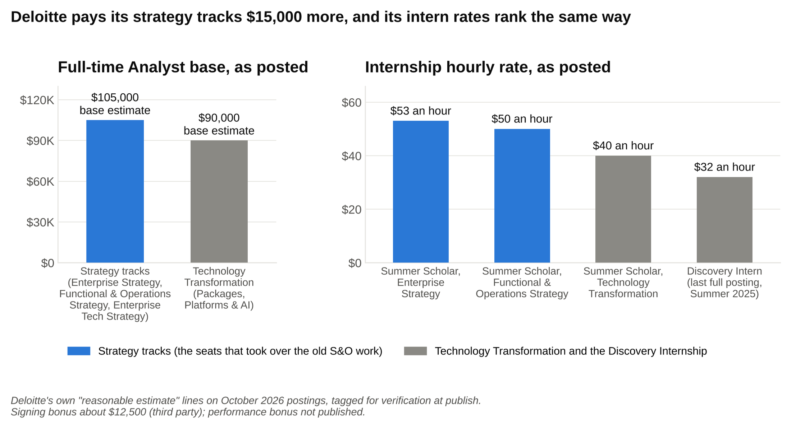
The $105,000 strategy tracks are the ones with the 3.3 GPA floor and the case interview, and the intern rates rank the tracks the same way.

Work the summer first. At $53 an hour, a 40-hour week is $2,120, and a ten-week internship is about $21,200 before overtime; the Functional & Operations Strategy rate of $50 an hour comes to $2,000 a week and $20,000 for the summer [VERIFY: hourly rates]. McKinsey's Business Analyst intern pay runs about $2,000 to $2,300 a week plus a housing stipend, per the figures in the McKinsey salary guide [VERIFY: McKinsey intern pay]. At the intern level, Deloitte's strategy tracks pay about the same per week as MBB; the gap opens at full time, and it opens in the bonus, not the base. A first-year McKinsey BA at roughly $110,000 to $112,000 base with a bonus around $30,000 lands near $140,000 to $160,000 all in [VERIFY: McKinsey figures]. A Deloitte strategy-track analyst at $105,000 base plus a $12,500 signing bonus and a modest performance bonus lands around $120,000 to $125,000 in year one [VERIFY: Deloitte all-in estimate]. That's a gap of roughly $15,000 to $40,000 depending on the McKinsey bonus, almost all of it bonus [VERIFY: gap arithmetic against current figures].

The $15,000 spread between the strategy tracks and Technology Transformation is Deloitte telling you which seats it treats as the former S&O. The $105,000 tracks carry the 3.3 GPA floor and the case interview; the $90,000 track carries a 3.0 floor and more technical screening [VERIFY: GPA and pay by track]. If a recruiter steers you from a strategy track toward Technology Transformation, you're being offered a different job, and the pay line on the posting is the honest signal.

For the strategy-side numbers under the Monitor name, the Monitor Deloitte guide has the Business Analyst base, bonus and signing ranges and the comparison with tier 2. I won't repeat them here, except to say they sit in the same band as the Enterprise Strategy numbers above [VERIFY: Monitor BA vs Enterprise Strategy Analyst pay parity]. Tier 2 firms such as Oliver Wyman and L.E.K. run within about 5 to 10 percent of MBB base, which puts them a notch above Deloitte's strategy tracks on base and well above on bonus [VERIFY: tier 2 base pay relative to MBB].

The Deloitte Consulting interview, step by step
Deloitte's own recruiting page sets the frame: "Expect two to three rounds of interviews, via either telephone, video, or in person," with "a mix of behavioral, technical, and case-based interviews, depending on the role" [VERIFY: deloitte.com recruiting tips wording]. Here's how that plays out for the strategy tracks, in order.

Step 1: the application. Resume, transcript or GPA, the office list, and the track. Pick one track and mean it. The Enterprise Strategy and Functional & Operations Strategy postings carry the same GPA bar and the same base pay, so the choice between them is about work, and the interviewer will ask why you picked yours. The current postings don't mention a cover letter [VERIFY: whether a cover letter field appears in the Summer 2027 application form]. The usual consulting resume rules apply unchanged: one page, numbers on every bullet, leadership above coursework.

Step 2: a screen, if your school uses one. Deloitte doesn't publish an online test for Consultative Offerings the way McKinsey publishes Solve or BCG publishes Casey. Some campuses report a pre-recorded video question set or a short recruiter phone screen between the application and the first round; others go straight to interviews [VERIFY: whether a video screen is used for Summer 2027 at core schools]. Treat the recruiter phone call as an interview: the person on it decides whether your name goes on the first-round list.

Step 3: the first round. Prep sites that track Deloitte describe one 30-to-45-minute behavioral interview and one or two 30-to-45-minute case interviews, usually with a Consultant or Senior Consultant and sometimes a Manager [VERIFY: first-round format at your school]. On campus this is often the same day for everyone invited; off campus it runs by video.

Step 4: the final round. A behavioral interview, a case, and for many tracks a group case: four to six candidates, a short prompt, about ten minutes to read it and twenty minutes of discussion while interviewers watch [VERIFY: whether the group case runs for your track]. I covered the group case and how it's scored in the Monitor guide and won't repeat it; the short version is that the people who get credit are the ones who move the group toward an answer and bring the quiet candidate in.

Deloitte's case is candidate led, conversational, and more often about operations than an MBB case is. Deloitte publishes its own expectations on a page called "Preparing for the Case and Scenario Interview," and the five steps it lists are worth memorizing because they're the rubric: understand the issue, identify the underlying assumptions, summarize the specific issues and findings, state recommendations, outline next steps and expected results [VERIFY: wording on the Deloitte case tips page]. The page also points to a practice case tool for entry-level Consultative Offerings candidates. Read the Deloitte case interview tips page before you read anything from a prep company; the firm's own language shows up in the interviewer's follow-ups.

Two things make these cases feel different from a McKinsey case, and I say that as someone who went through McKinsey's process. First, you drive. The interviewer gives you a prompt and some data, then waits for your structure, your questions and your recommendation, closer to a BCG or Bain case than to McKinsey's step-by-step style. Second, the prompts lean practical. Fewer "should we enter Brazil" questions, more "the client's on-time delivery rate fell and the CFO wants a plan by Friday." The case skills are the same ones in WSG's guide on how to structure a case under pressure; the flavor is operations.

Here is a short one, worked the way an interviewer would expect.

The prompt. Northline Foods is a regional food distributor. A year ago it delivered on time 96 percent of the time. Today it's 88 percent, two of its largest grocery customers have threatened to switch suppliers, and the CFO wants to know what the drop is costing and what to do about it.

Step one, understand the issue. On-time delivery fell eight points in a year. The client cares for two reasons: the direct cost of each late delivery (credits, redelivery, spoiled product) and the risk of losing accounts. Clarify both before touching a number. Ask how many deliveries a week the company runs now versus a year ago, what a late delivery costs, and whether anything changed in the business. Say the interviewer answers: 2,000 deliveries a week now, 1,750 a year ago, about $150 per late delivery, and the company added a chilled product line last spring.

Step two, identify the assumptions and size the problem. The cost of lateness is the number of late deliveries times the cost per late delivery. Lay it out:

Item | Last year | This year
Deliveries a week | 1,750 | 2,000
On-time rate | 96 percent | 88 percent
Late deliveries a week | 70 | 240
Cost per late delivery | $150 | $150
Weekly cost of late deliveries | $10,500 | $36,000
Annual cost of late deliveries (52 weeks) | $546,000 | $1,872,000

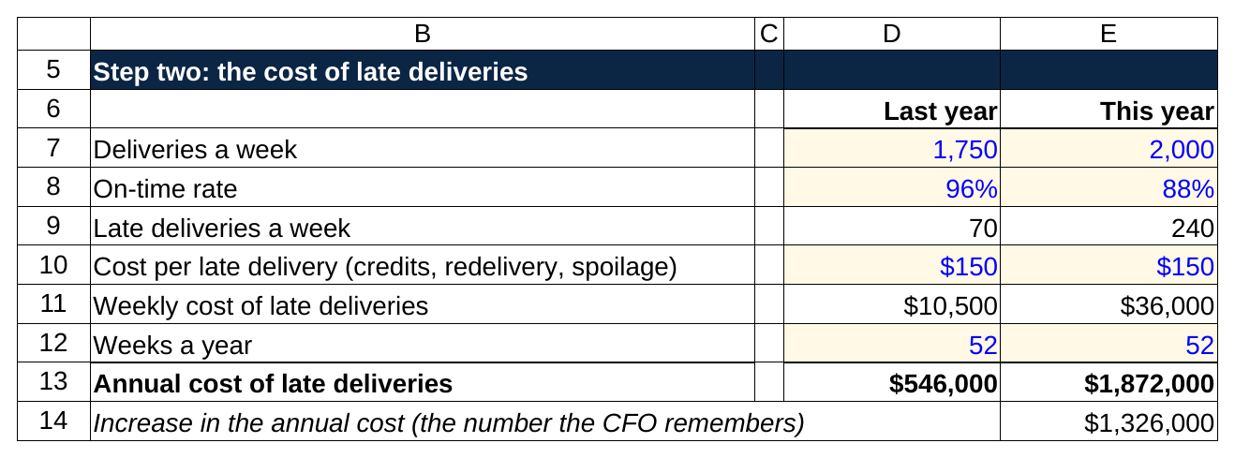
Late deliveries went from 70 a week to 240, and at $150 each the annual cost went from $546,000 to $1,872,000, about $1.3 million more.

Last year's late deliveries were 1,750 times 4 percent, or 70 a week. This year's are 2,000 times 12 percent, or 240 a week. The weekly cost went from $10,500 to $36,000, and the annual cost from $546,000 to $1,872,000. The problem is worth about $1.3 million a year more than it was, before counting any lost account. Say that number out loud; it's the one the CFO will remember.

Step three, find the cause. Structure the possible causes in two branches: capacity (can the trucks and the warehouse physically do 2,000 deliveries a week?) and execution (routing, loading, driver availability). Ask for fleet data. The interviewer gives you 40 trucks, each able to handle about 50 deliveries a week, so capacity is 2,000 a week. Last year demand was 1,750 against 2,000, about 88 percent utilization, which leaves room for a broken-down truck or a bad weather day. This year demand is 2,000 against 2,000. There's no slack, so every breakdown turns into late deliveries. Then the second clue: the new chilled product line added a separate pick in the warehouse (a second trip to collect items before each truck can leave), and loading time per truck per day rose from 40 minutes to 55. Fifteen extra minutes, five days a week, across 40 trucks is 50 truck-hours a week. If a delivery stop takes about 30 minutes, that's roughly 100 deliveries a week of capacity lost to loading. So effective capacity is closer to 1,900 against demand of 2,000, and the on-time rate collapses.

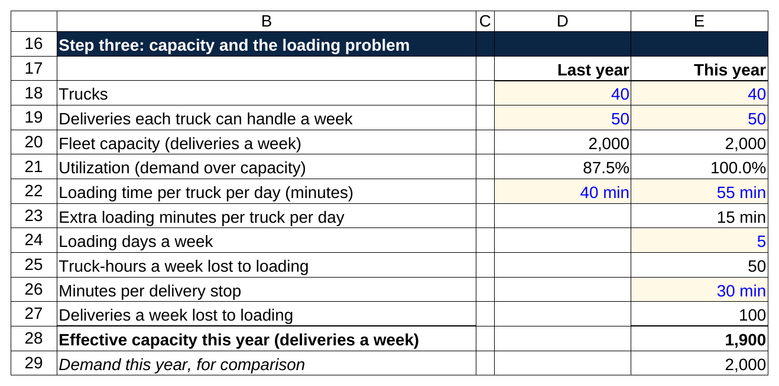
Forty trucks at 50 deliveries a week is 2,000 of capacity, and 15 extra loading minutes a day costs about 100 deliveries a week, so effective capacity is 1,900 against demand of 2,000.

Step four, recommend. Two levers, cheapest first. Lever one: fix the loading problem by re-slotting the chilled pick (moving the chilled items so pickers don't cross the warehouse for them) and staging pallets the night before, which recovers the 100 deliveries a week and costs about $120,000 once for racking and process work. Lever two: lease three more trucks with drivers at about $150,000 a year each, or $450,000 a year, adding 150 deliveries a week of capacity. Together they take effective capacity from about 1,900 to about 2,150 against demand of 2,000, or about 93 percent utilization. That's not quite the 88 percent the company ran at when it hit 96 percent on time, but it puts slack back in the schedule for a broken-down truck or a bad weather day.

Lever | Capacity recovered or added (deliveries a week) | Cost
Re-slot the chilled pick, stage pallets the night before | about 100 | $120,000 one time
Lease three trucks with drivers | 150 | $450,000 a year
Combined | about 250 | $120,000 once plus $450,000 a year

If on-time delivery returns to 96 percent, late deliveries fall to 80 a week (2,000 times 4 percent), and the annual cost of lateness falls to $624,000 (80 times $150 times 52). Against today's $1,872,000, that saves $1,248,000 a year. Net of the trucks, the company keeps about $798,000 a year, and about $678,000 in year one after the one-time $120,000. The recommendation: fix loading this month, sign the truck leases this quarter, and call the two grocery accounts with the plan before they switch.

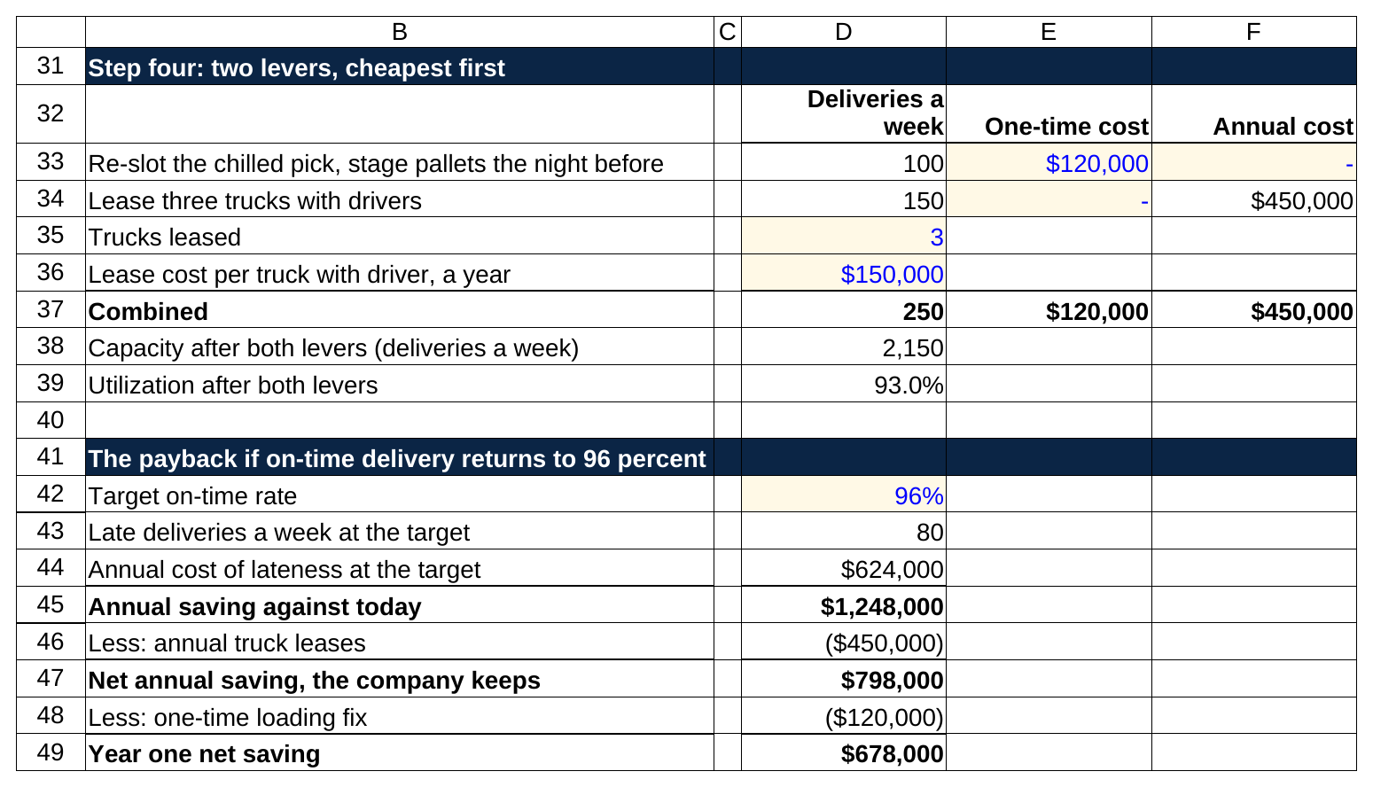
The loading fix recovers 100 deliveries a week for $120,000 once, three leased trucks add 150 for $450,000 a year, and the company keeps about $798,000 a year.

Step five, next steps and risks. Confirm the $150 cost per late delivery with real credit data, check whether the chilled line's volume keeps growing (if it does, three trucks won't hold), and set a weekly on-time dashboard so the client sees the recovery. That's the whole case in about twenty minutes, and every number in it ties, which is the part interviewers check.

The behavioral half of a Deloitte interview carries as much weight as the case, and it's the half that decides between two candidates who both did the math. The questions are standard (a time you led, a time you failed, a time you handled conflict), but the follow-ups dig at whether you can work inside a client's organization for months without annoying people. Have three stories ready and keep each under two minutes; the general prep in WSG's consulting interview guide applies.

The recruiting timeline for Summer 2027 and Summer 2028
Deloitte's Summer Scholar window runs in the fall before the internship summer, months after MBB has closed for the same summer. You apply in the fall of the academic year before the internship, not fifteen months out. That's good news for a junior who missed the MBB windows in spring 2026. The consulting recruiting timeline has the MBB dates; here is Deloitte's side.

Program | Who it's for | When to apply | Status on October 5, 2026
Summer Scholar, Summer 2027 (strategy tracks) | Juniors graduating by Spring or Summer 2028 | Posted late summer 2026; recruiting ends November 1, 2026 [VERIFY: posting and close dates] | Open
Summer Scholar, Summer 2027 (Technology Transformation) | Same class, lower GPA bar | Recruiting ends December 31, 2026 [VERIFY: close date] | Open
Analyst, full time, Summer 2027 start | Seniors graduating by Spring or Summer 2027 | Recruiting ends November 1, 2026 [VERIFY: close date] | Open
Discovery Internship, Summer 2027 | Sophomores (Class of 2029) | Prior cycle closed in December; expect postings fall and winter 2026 [VERIFY: Summer 2027 Discovery window] | Not yet posted
DNLC 2027 | Sophomores and juniors | Through your campus recruiter; dates vary by office [VERIFY: 2027 DNLC dates] | Ask your recruiter
Summer Scholar, Summer 2028 | Juniors graduating by Spring or Summer 2029 (Class of 2029) | Expect postings August to September 2027 with a late October or November 2027 close, matching this year's pattern [VERIFY: Summer 2028 window] | Not yet posted
Discovery Internship, Summer 2028 | Today's freshmen (Class of 2030) | Expect late 2027 into early 2028 [VERIFY: window] | Not yet posted

If you're a junior reading this in October 2026, the Summer 2027 Summer Scholar window is open now and closes in weeks, so apply this week rather than after midterms. Deloitte's postings close on the printed date, and the recruiters I've spoken with read applications as they arrive, so an application on the last day competes with a pile that's already been through first rounds [VERIFY: whether Deloitte reviews on a rolling basis].

If you're a sophomore now, graduating in spring 2029, you have two shots. The first is Discovery for Summer 2027, if the posting appears this winter and your GPA clears the floor. The second, and the one that leads to the full-time offer, is the Summer 2028 Summer Scholar cycle in fall 2027. Between now and then, the useful moves are a Discovery application, a DNLC nomination through your campus recruiter, and one coffee chat per semester with an analyst in the office you'd pick.

Here's the comparison that matters for planning. For Summer 2028 internships, MBB applications are expected to run January through August 2027 [VERIFY: McKinsey, BCG and Bain Summer 2028 windows], and Deloitte's Summer Scholar postings are expected in August or September 2027. A sophomore who applies to MBB in spring 2027 and doesn't convert still has the full Deloitte window ahead of them that fall. Plan the case prep once, in winter 2026 to 2027, and use it twice.

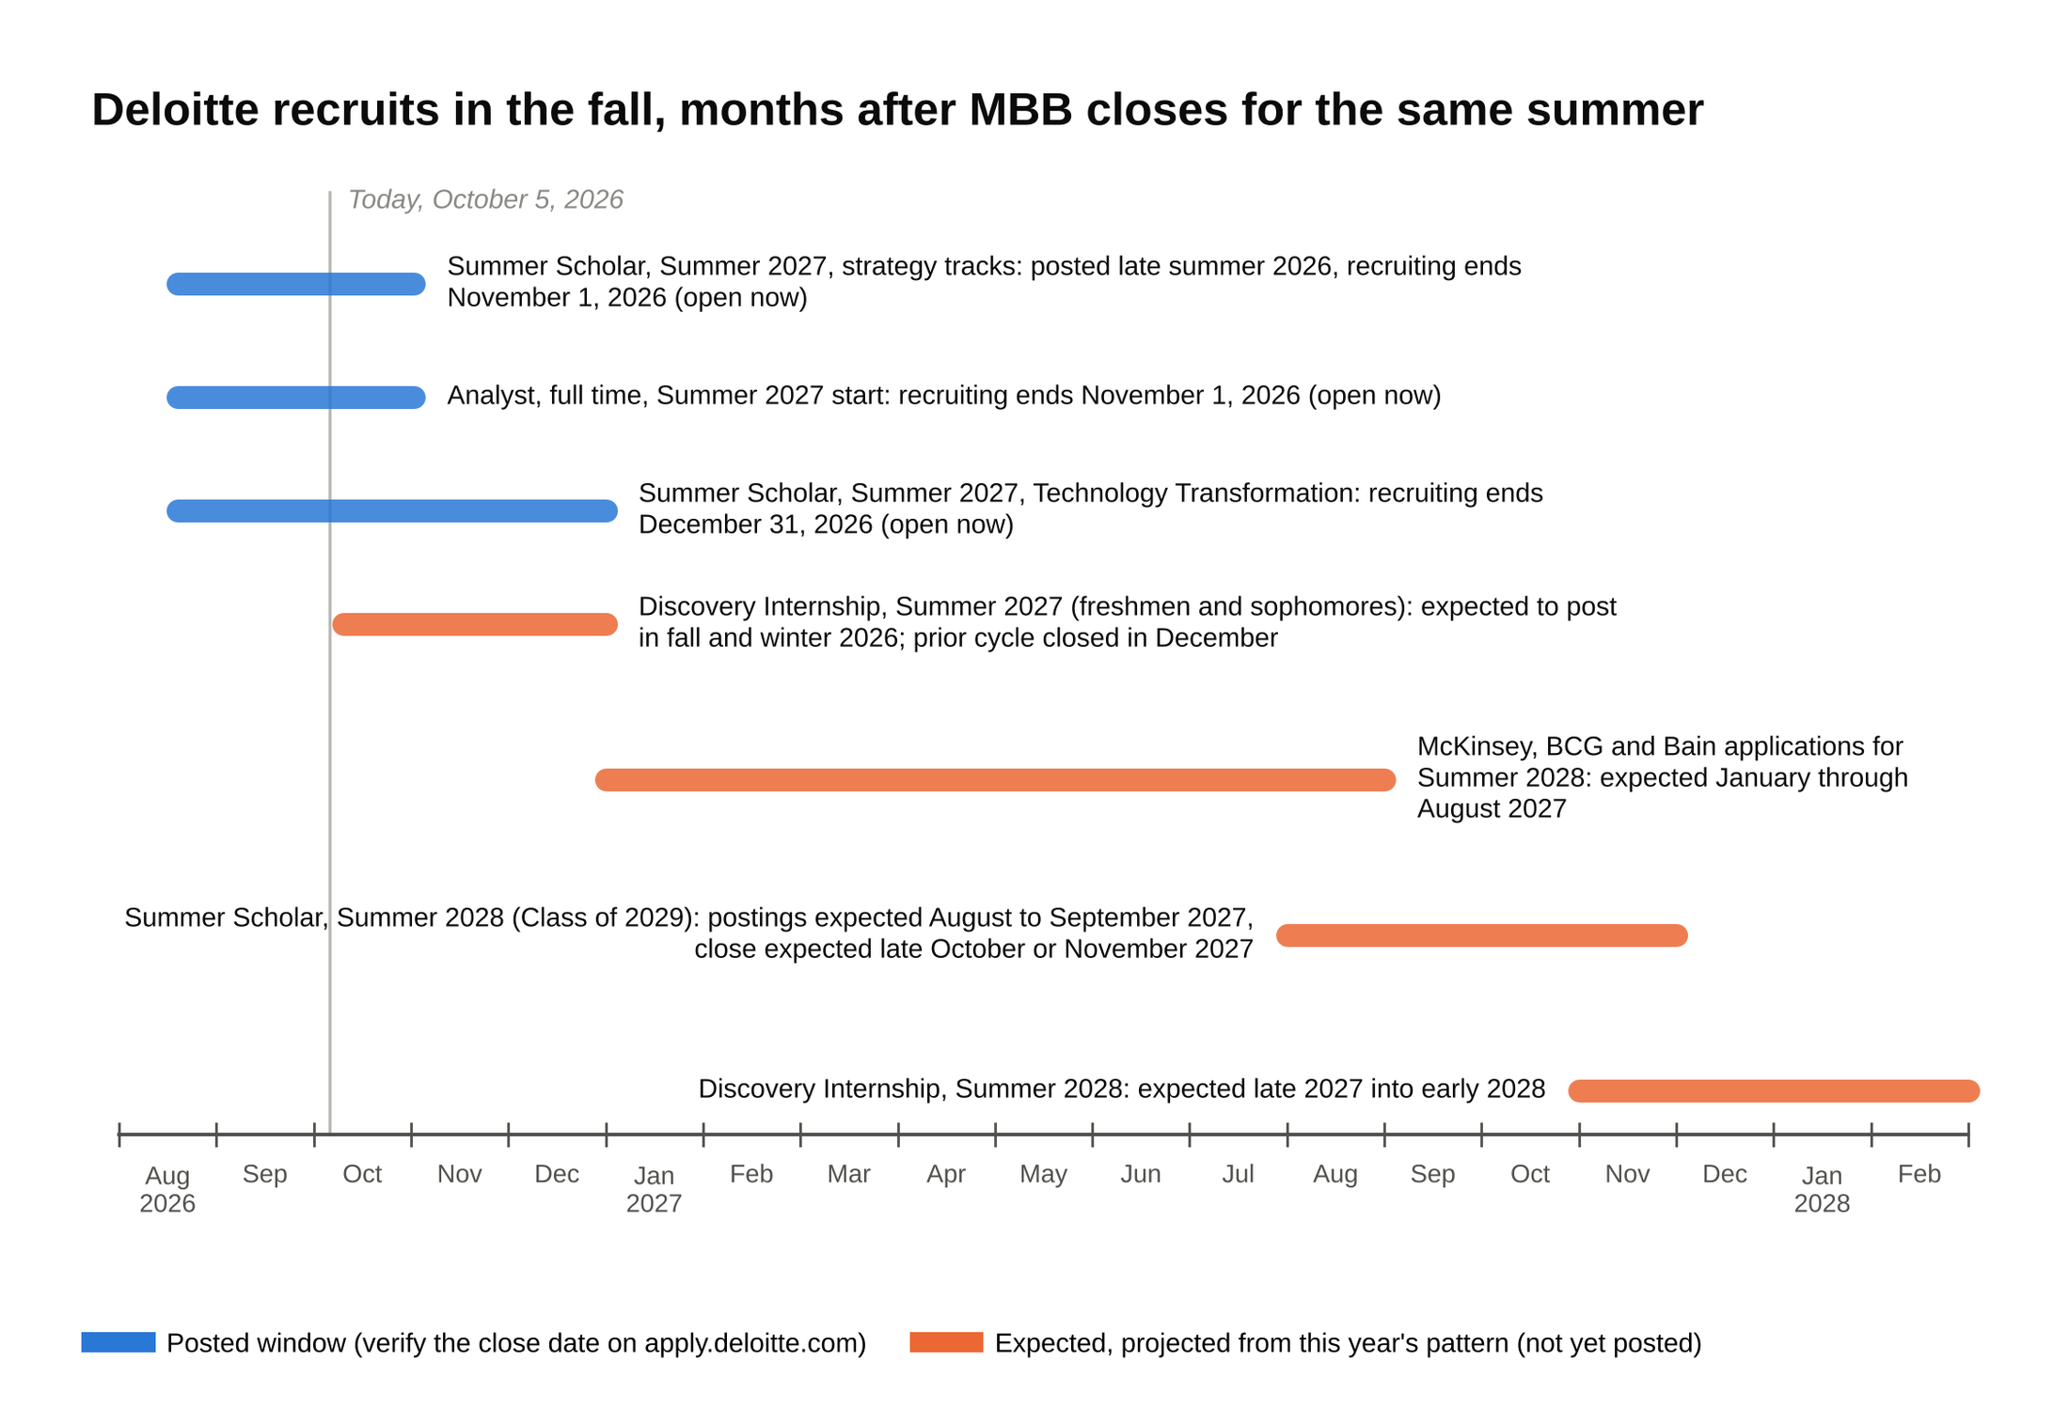
A sophomore who misses the MBB spring 2027 windows still has Deloitte's Summer 2028 window ahead of them that fall, so plan the case prep once and use it twice.

Exits and the Graduate School Assistance Program
Deloitte analysts exit to the same four places MBB analysts do, with corporate strategy and operations roles ahead of private equity. Three to four years in, the common moves are a strategy or corporate development team at a client-sized company, an operations or "portfolio operations" role at a private equity firm (the people who work inside the companies a fund owns, as opposed to the deal team), a product or strategy role in tech, and an MBA. Direct moves to a PE deal team are rare from Deloitte, rarer than from Monitor, and rarer still than from MBB; the exceptions tend to come out of the M&A work in the Strategy & Transactions path, where an analyst has spent two years on diligence and integration. The consulting exits guide ranks the options across firms.

Two Deloitte-specific exits deserve a line each. The first is internal: an analyst who wants pure strategy work can move toward Monitor Deloitte teams inside the Strategy & Transactions business without changing employers, which is easier than lateraling into an MBB firm. The second is the lateral to MBB itself, which happens at the Consultant level more than at Analyst, usually after a strong project in a practice MBB is hiring for (supply chain and M&A integration have been the busiest).

The MBA route has a program name: the Graduate School Assistance Program, GSAP. GSAP is real but smaller and more selective than MBB sponsorship, so the analysts who use it earn it on ratings from year one. It exists (Deloitte runs a portal for it at gradschool.deloitte.com for US and USI employees), but Deloitte's public page for it now redirects to the general careers site, so the details below come from third-party reporting and need a check [VERIFY: GSAP terms on an internal or current Deloitte source]. As reported, GSAP covers full tuition at approved programs for high performers, with eligibility after about two years and most people taking it at three to four, and it requires returning to the firm as a Senior Consultant for a commitment period after the degree [VERIFY: tuition coverage, eligibility and return commitment]. The same reporting puts MBB sponsorship at full tuition plus a living stipend with a two-year return. The practical difference is selection: MBB sponsorship is broadly available to analysts in good standing, while GSAP is performance gated and goes to a smaller share of each class [VERIFY: GSAP selectivity].

Who should pick Deloitte Strategy and Operations work over MBB or tier 2
Framed positively, because the firm earns the choice for a specific kind of student.

Deloitte is the right call for a student who wants to see a plan get built, rather than only presented. If the part of a case that excites you is the "and then what" (the new accounting system goes live, the supply chain gets rerouted, the two companies merge their finance teams), the Functional & Operations Strategy track puts you on that work in year one. MBB analysts rarely stay past the recommendation.

Deloitte is the right call for a student at a wide-list school with a 3.4 to 3.6 GPA who wants a consulting seat with real strategy content. The posted floor is 3.3 with 3.5 preferred on the strategy tracks [VERIFY: GPA bar], the application is open, and the firm interviews at far more campuses than MBB. A 3.5 at a large public university is a competitive Deloitte application and a long shot at McKinsey.

Deloitte is the right call for a student who wants a specific industry or function early. Because staffing runs through offerings and industries, an analyst who wants supply chain, or healthcare operations, or finance transformation can say so and mostly get it. At MBB you take what the staffing model gives you for two years.

MBB or tier 2 is the better call if you want the broadest possible exit set in two years, if you want the highest bonus, or if the thing you love about cases is the variety. None of those are knocks on Deloitte. They're a description of a different job.

On the "why Deloitte" answer, here's what works and what doesn't.

Why Deloitte?
Don't say: "Deloitte is a global leader with a great culture."
Say: "I want the Functional & Operations Strategy track because the supply chain work runs through implementation, and the project I did for my school's food pantry taught me I like the part after the recommendation. I spoke with an analyst in the Chicago office who described a year on a distribution network redesign, and that's the work I want to spend my first two years on."

Why this track and not Monitor or MBB?
Don't say: "I applied to MBB too, this is my backup."
Say: "I'm applying to strategy seats across firms, and Deloitte's operations strategy work is on that list on its own merits because the projects go through to the build. The $105,000 posting and the 3.3 floor tell me the firm treats this as a strategy seat, and the interview is the same case I'd run anywhere." [VERIFY: figures quoted in the sample answer match the live posting]

What does Deloitte's Strategy & Operations group do?
Don't say: "I think it's the same as Monitor Deloitte."
Say: "S&O was the old name for the strategy and operations service line. Today that work sits in the Enterprise Strategy and Functional & Operations Strategy tracks, and Monitor Deloitte is the strategy practice inside Strategy & Transactions. I'm applying to Functional & Operations Strategy because the finance transformation and supply chain practices are where I want to start."

Walk me through a time you worked with someone difficult.
Don't say: "My group member didn't do any work, so I did it all myself."
Say: "On a two-month club project, one teammate missed two deadlines. I asked what was going on, found out his part depended on data he couldn't get, got it for him, and we re-split the remaining work so his piece was something he could finish. We delivered on time. I'd rather fix the blocker than route around the person."

What to do this week
If you're a junior: open apply.deloitte.com, read the Enterprise Strategy and Functional & Operations Strategy Summer Scholar postings end to end, pick one, and submit before the November 1 close [VERIFY: close date]. Then read Deloitte's own case tips page and run three operations-flavored cases out loud with a partner, each one ending in a number you can say to a CFO.

If you're a sophomore: find your campus recruiter's name through your career center, ask about DNLC and the Discovery posting for Summer 2027, and set a reminder for August 2027 for the Summer 2028 Summer Scholar window. Caleb submitted his Functional & Operations Strategy application the week after our call, ran his cases, and is interviewing this month. The practice his cousin joined doesn't exist by that name. The job does, and it's open.

